MOOC Development Timeline

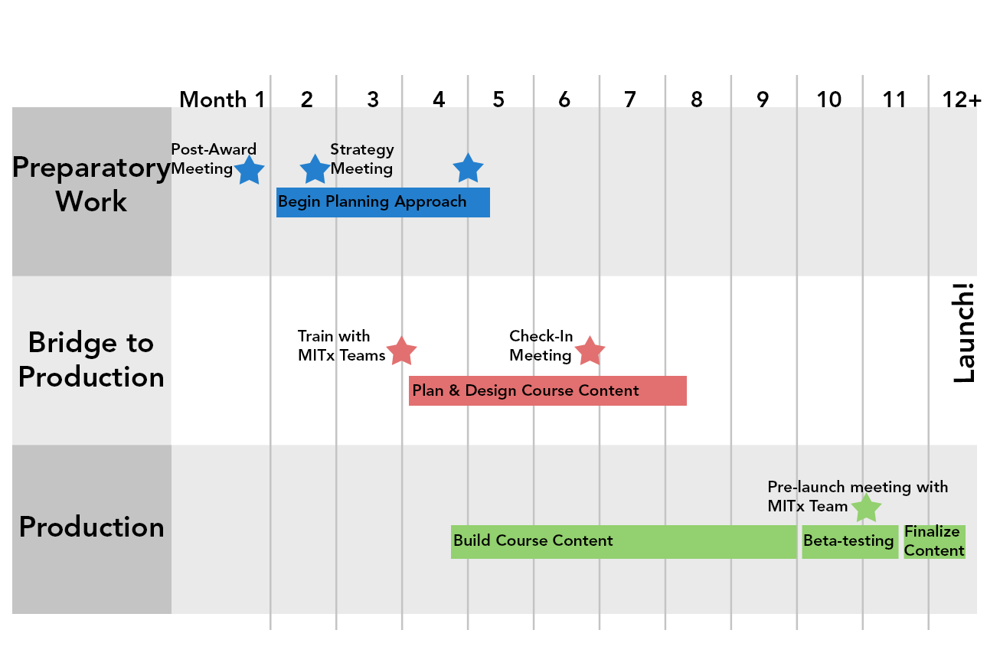

Preparatory Work | Timeline dates are from the time of grant approval.
Action Item |  | Duration | Estimated Dates
Notification of project approval |  | Approval Date | _ _ - _ _ - _ _ _ _
Faculty and content contributors sign Intellectual Property Agreement (IPA) via DocuSign  - Signing of the IPA initiates the process to transfer grant funds to the department |  | 20 Minutes | _ _ - _ _ - _ _ _ _  (one to two weeks from approval)
Post-Award Meeting  - Expand on key points from grant proposal to clarify project needs  - Discuss possible course team configuration and roles  - Introduce the MITx development process and team roles |  | One Hour | _ _ - _ _ - _ _ _ _  (two to three weeks from approval)
Begin Planning  - Faculty begins to consider approach to course content and assessment |  | ongoing | _ _ - _ _ - _ _ _ _  (begin after Post-Award Meeting)
Strategy Meeting  - Determine expected development timeline  - Explore potential learning strategy/pedagogy  - Discuss primary learning goals |  | One Hour | _ _ - _ _ - _ _ _ _  (one to two months from approval)

Bridge to Production – Planning Period | Timeline dates are from the time of grant approval.
Action Item |  | Duration | Estimated Dates
Begin to design course content  - Draft course outline  - Plan initial production schedule  - Investigate assessment strategies  - Consider Feature-Based Enrollment approach for learner experience  - Look into intellectual property usage |  | ongoing | _ _ - _ _ - _ _ _ _  (begin two to four months from approval)
Schedule Trainings with OWLS Teams  - Platform Training  - IP Training  - Media Orientation  - Accessibility Discussion |  | One to Two Hours | As appropriate based on plan(s) from Strategy Meeting and course team availability;  Email your OWLS Project Administrator to schedule

It is important that course teams maintain regular communication with the OWLS team during the development process. If you have any questions or concerns, please contact your Project Administrator or mitx-pm@mit.edu.

Production Work | Timeline dates progress to the course launch date.
Action Item |  | Duration | Estimated Dates
Begin Building Course  - Content creation  - Finalize assessment(s) strategies & build  - Choose reading(s)  - Supplemental text  - Media production  - Updating content based on IP tracking  - Finalize policy on verified and audit learner experience |  | Nine+ months | _ _ - _ _ - _ _ _ _  (nine months before launch)
Build a representative week  - Provides a template for the rest of the course  - Allows experimentation with different content styles  - Helps provide realistic time management for the rest of the project |  | One month | _ _ - _ _ - _ _ _ _  (nine months before launch)
Check-In Meeting with OWLS  - Revisit Strategy Meeting notes  - Review the representative week  - Revise representative week and iterate of development plan based on discussion |  | One hour | _ _ - _ _ - _ _ _ _  (eight to nine months before launch)
Meet with individual OWLS team to review development status  - Allows MITx team to help you troubleshoot any current challenges or concerns  - Provides opportunity for collaborative planning |  | ongoing | _ _ - _ _ - _ _ _ _  _ _ - _ _ - _ _ _ _  _ _ - _ _ - _ _ _ _
Create About Page  - Submit form and assets to OWLS  - Review and approve preview page |  | One week | _ _ - _ _ - _ _ _ _  (three months before launch)
About Page is published and enrollment opens |  | - | _ _ - _ _ - _ _ _ _  (two months before launch)
Complete development:  - Final videos uploaded with transcripts  - Begin clearing outstanding IP objects  - Finalize content on platform  - Faculty completes initial review |  | Two months | _ _ - _ _ - _ _ _ _  (two months before launch)
Pre-Launch meeting with OWLS staff  - Review launch checklist  - Finalize course moderation/management with OWLS  - Identify beta-testers, TAs  - Review learner communication plan |  | One hour | _ _ - _ _ - _ _ _ _  (two months before launch)
Beta test course  - Course team makes final updates/changes based on findings & OWLS recommendations |  | One to two month(s) | _ _ - _ _ - _ _ _ _  (one to two months before launch)
Finalize IP object status |  | One month | _ _ - _ _ - _ _ _ _  (one month before launch)
LAUNCH! |  |  | _ _ - _ _ - _ _ _ _

